1.Create a GitHub account.

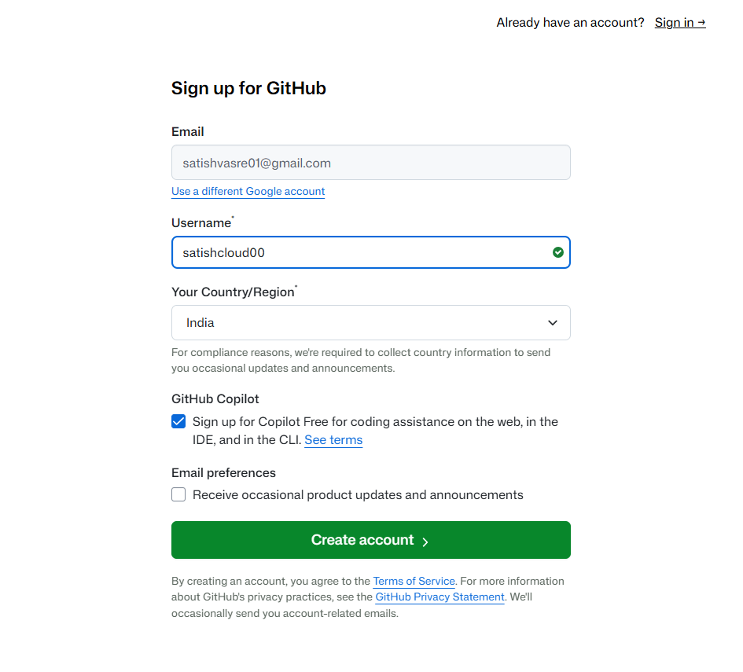
Step 1: set username

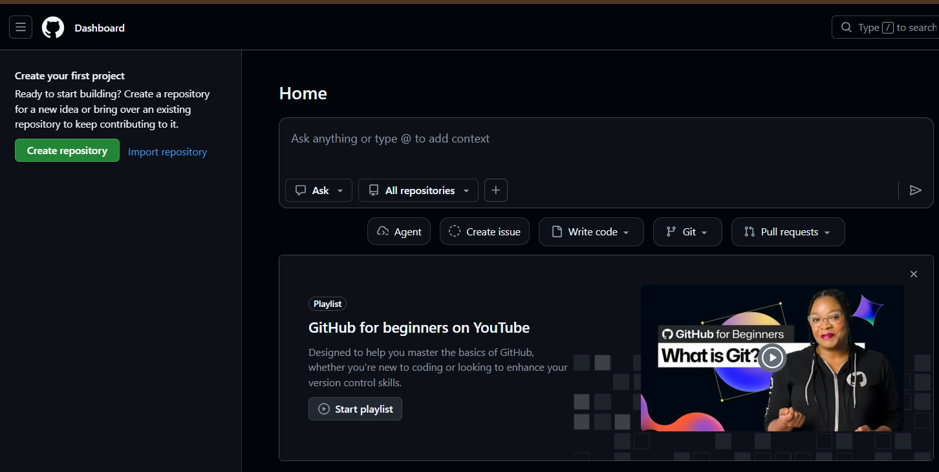

2.Set up MFA (Multi-Factor Authentication) for the GitHub account using a mobile app.
Step :1 Profile Go to setting

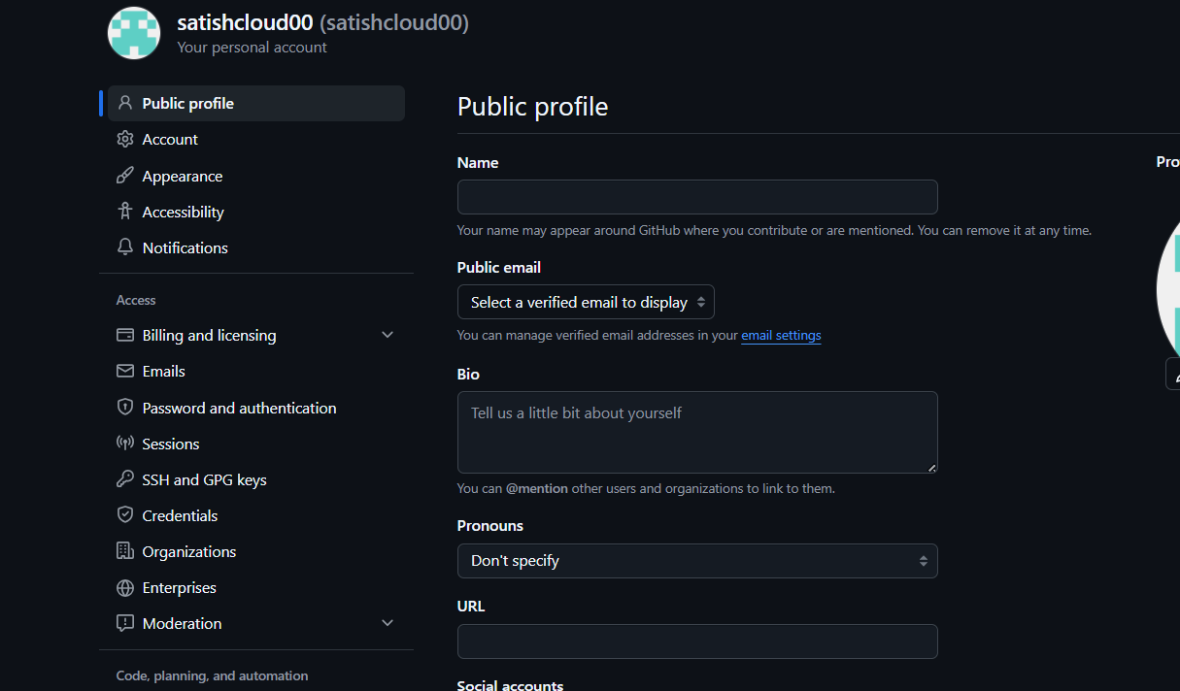

Step 2: Go to Password and Authentication
- In the left menu, click Password and authentication.
- Scroll to Two-factor authentication.
- Click Enable two-factor authentication.
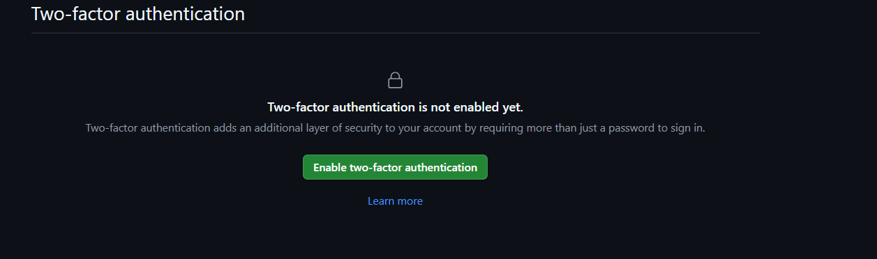

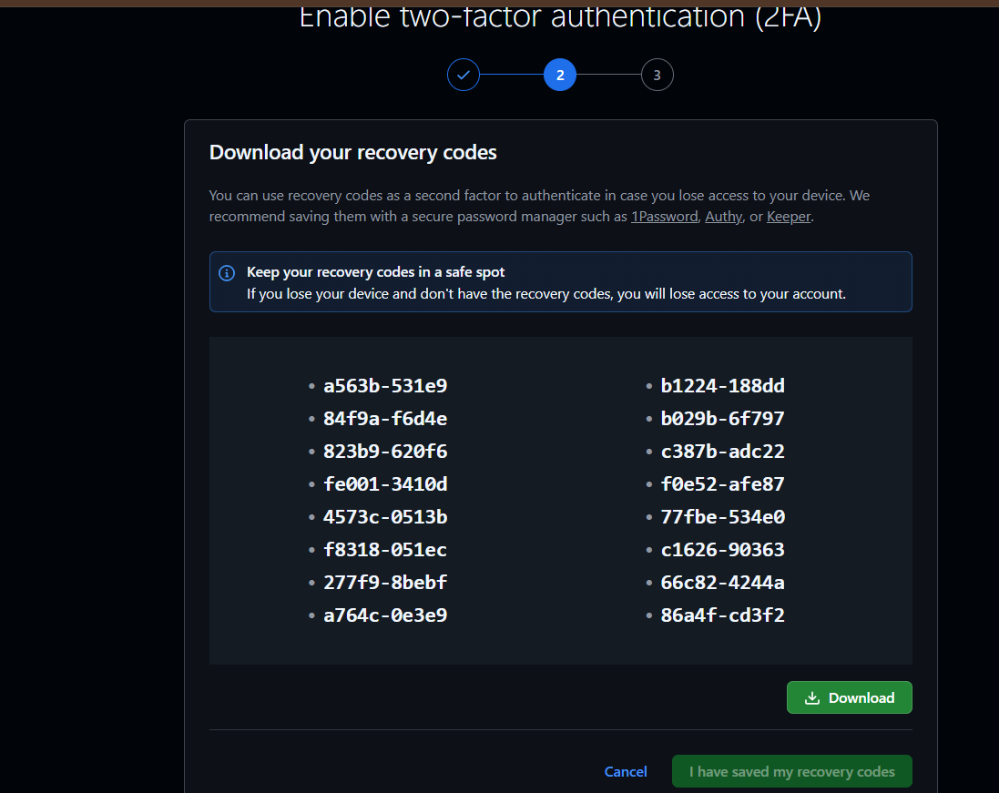
Step 3: Choose an Authentication Method
Select Authenticator App.
GitHub will display a QR code.

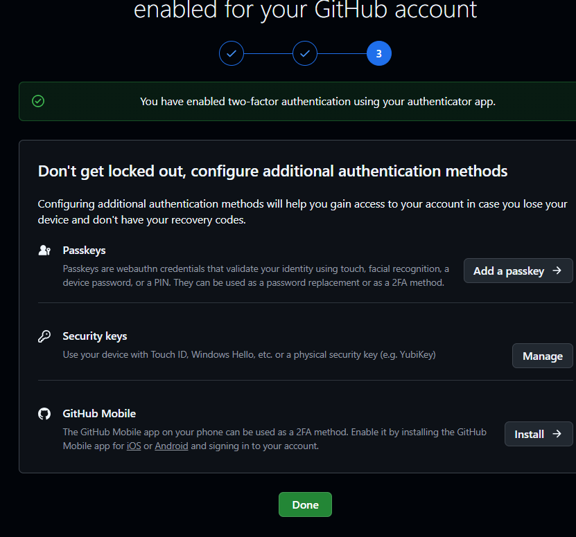

3.Execute all commands shown in the video.
Step 1: check git version
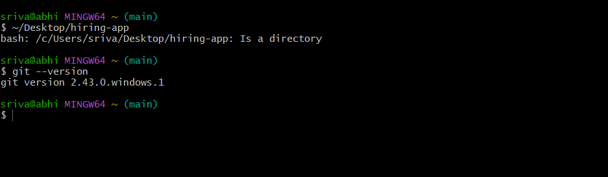

Step 2: created directory name : hiring-app and also created file Dockerfile
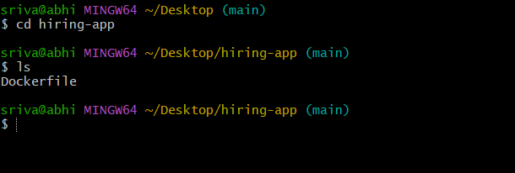

Step 3: check the changes
Command : git status
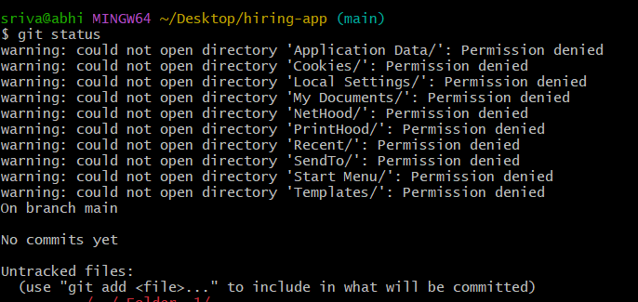

Step 4: track directory
Command : git init
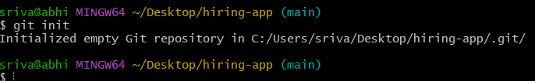
Check hidden file
Command : ls -a
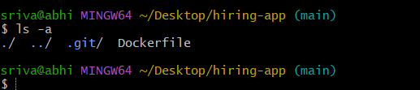
See configuration
Cd .git/
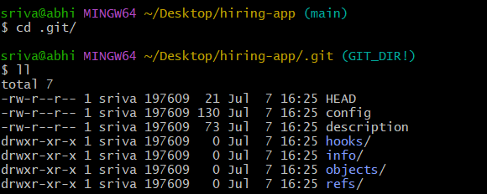

Check git status
Command : git status
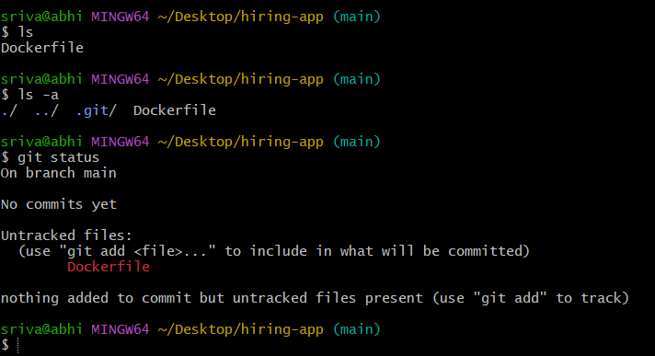

Create sample file satish
Command : touch satish
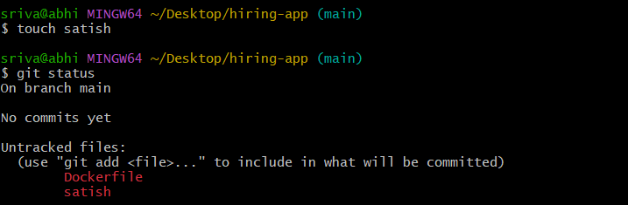
Delete file
Rm -rf .git/

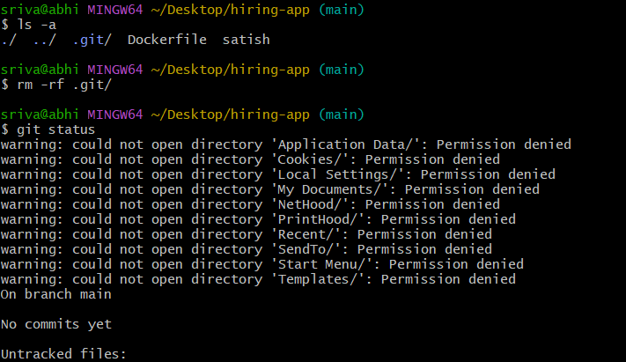
Again need to initialize git init
Command : git init 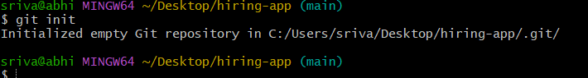

Check status
Command : git status
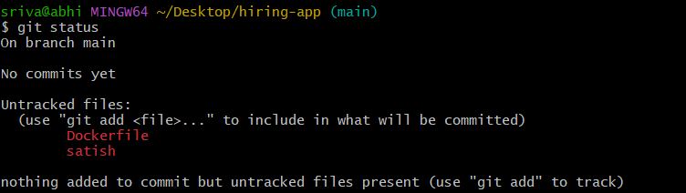

Now we need to check configure username and email
Command : git config --list
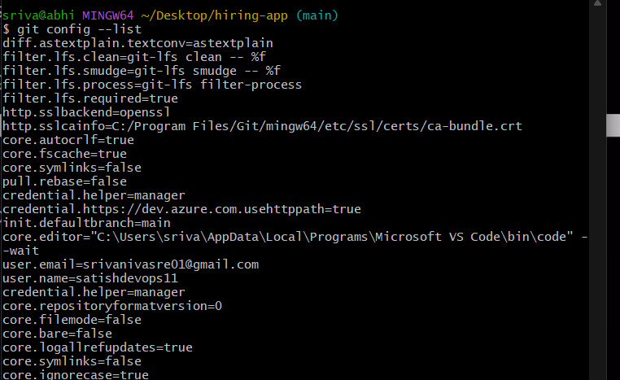
If don’t have configuration of username and email need to configure
Note : without cofiguring username and emial we can’t push file from local to cetral
Command : git config --global user.name “satishcloud00”
Command : git config --list
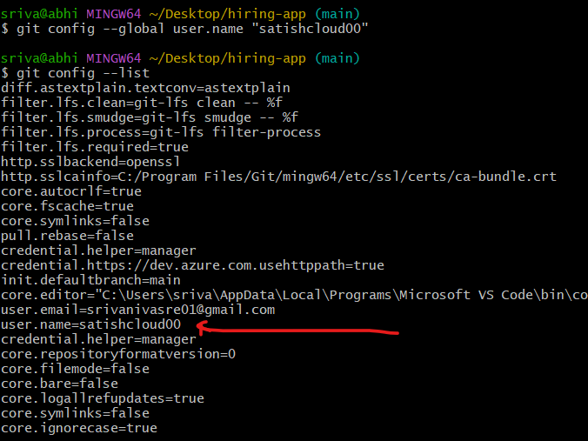

Email configuration
Command : git config --global user.name “satishvasre01@gmail.com”
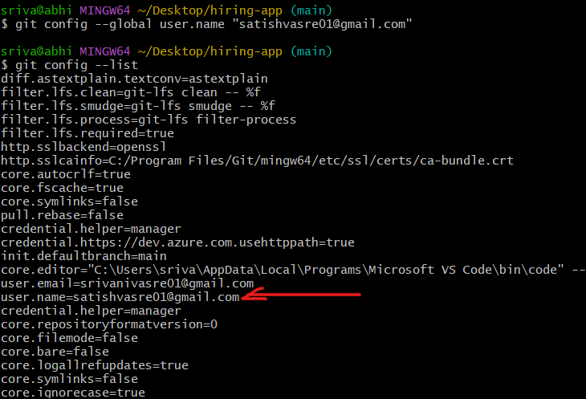

Push from local system to contral repository
Step 1: need to move file from untracking to tracking area
Command : git add
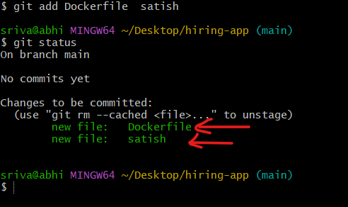

How to push all file at once instead of entering manualy
Step 1: create sample files a b c d e
Command : touch abacde
Command : ls
Check status of untrack files
Command : git status
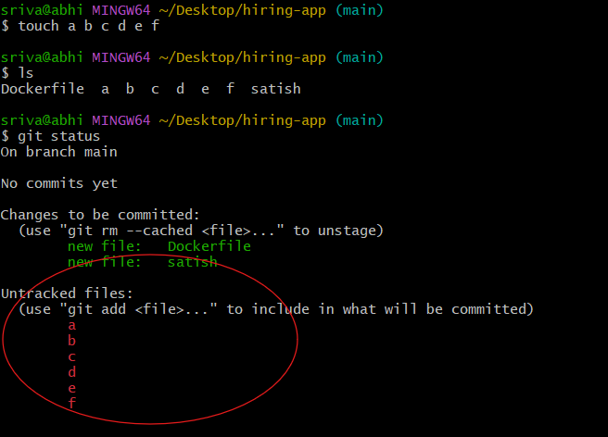
Step 2: track all file a b c d e
Command : git add .
. dot means all file
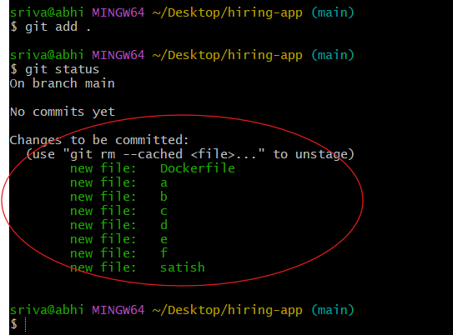

Commit chnages : it will store copy in the machine or it will track chnages
Command : git commit -m
-m ---------- measage or comment
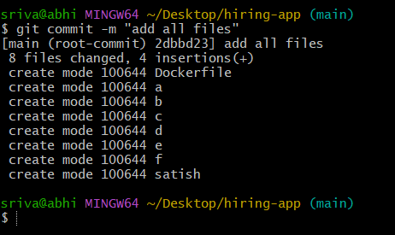
No commit pending
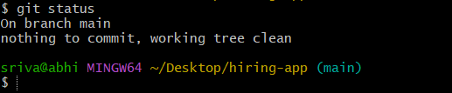
To check commit number or id or if want checj change
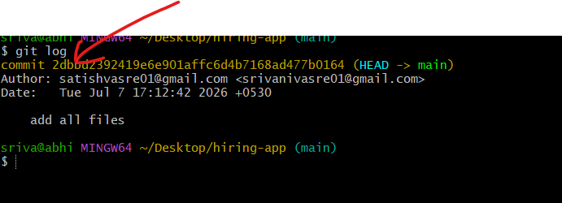
Command : git log -4

Now we want to store all files in central repository (github)
Step : 1 go to gitbut and create repository 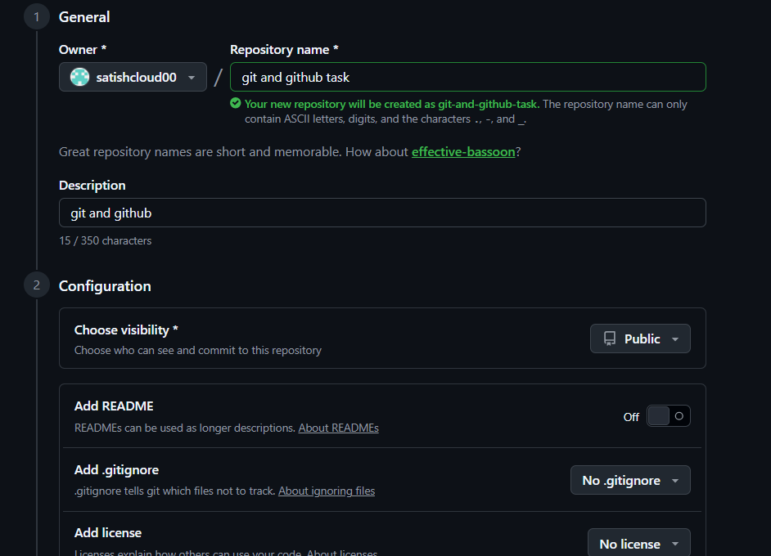
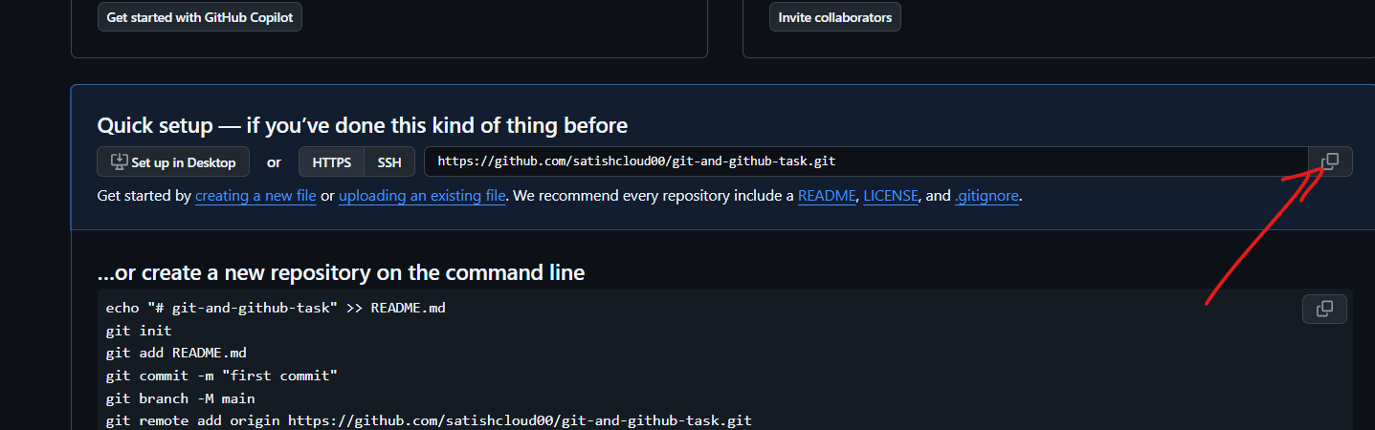

Step 2: in terminal -check if any address configure or not
Command : git remote -v
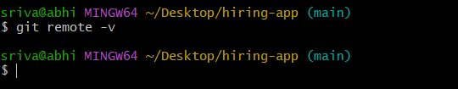

Step 3: add SSH url (copy from gitbut and paste)
Command : git remote add origin git@github.com:satishcloud00/git-and-github-task.git
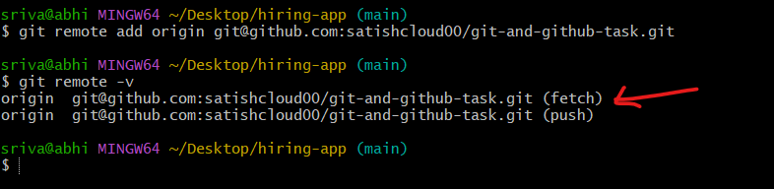

Before pash we need have connectivity we need ssh key
Generate SSH key
Command : ssh-keygen
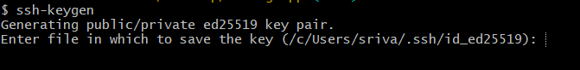

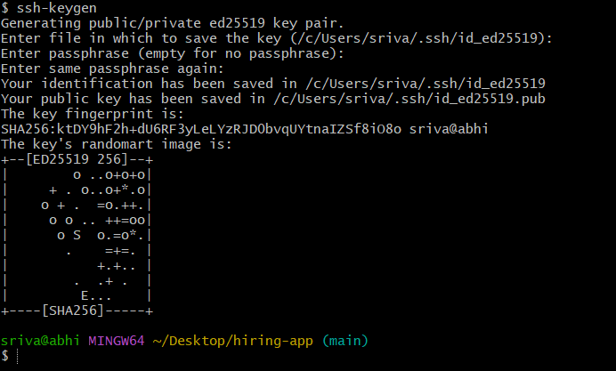

Read ssh key
Copy public key and go to git tub
command : cat /c/Users/sriva/.ssh/id_ed25519.pub
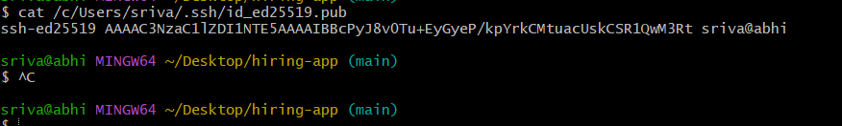

Got to git hub profile --- setting -- ssh and gpg keys
Copy ssh key terminal and paste in github
Click on add SSH key
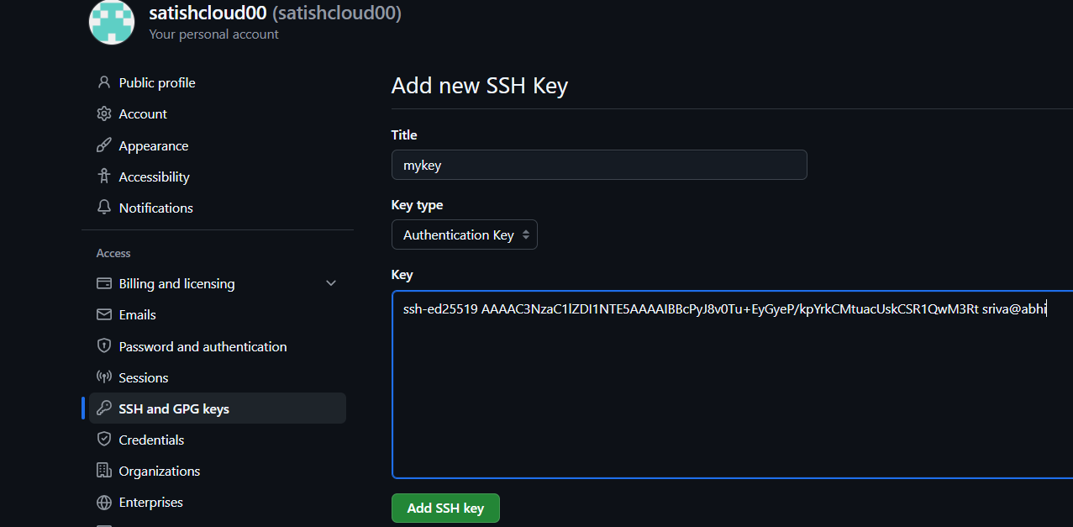

Now we can push
Command : git push -u origin main
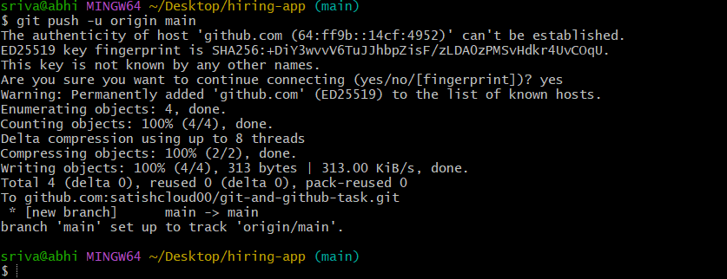

Got to gihub and refresh page
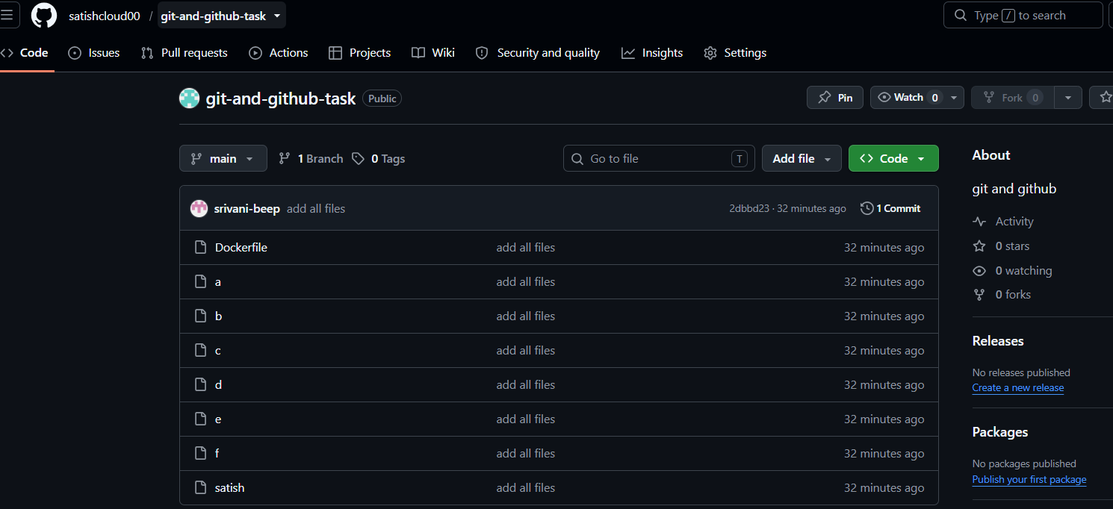

Scenario 1: If a file is deleted from the local system, it will not be deleted from the central repository until the changes are committed and pushed.

✅ The file is deleted only from your local working directory.
✅ The file still exists on GitHub because you haven't informed Git about the change.

Step 1: delete file from locate system
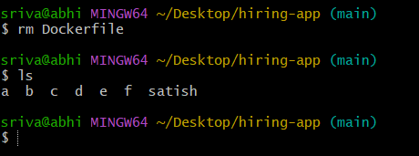
This file deleted from local
Step 2: to delete from github or to sync local and central
Input

Step 3: check status
Command : git status
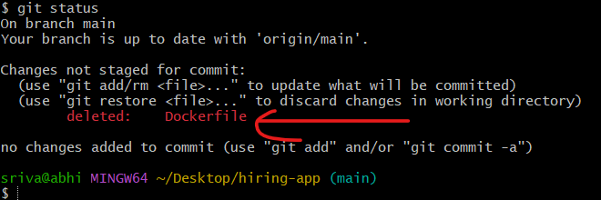

Step 4: update the changes
Command : git add .
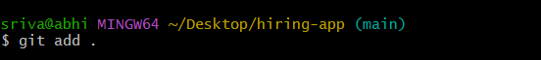
Step 5: commit the changes
Command : git commit -m “deleted dockerfile”
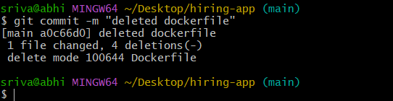

Step 6: push all changes to central repository
Command : git push -u origin main
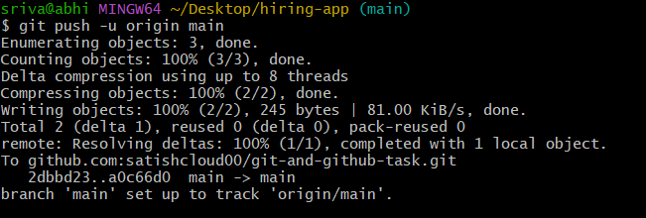
Got and github and refresh
Dockerfile deleted
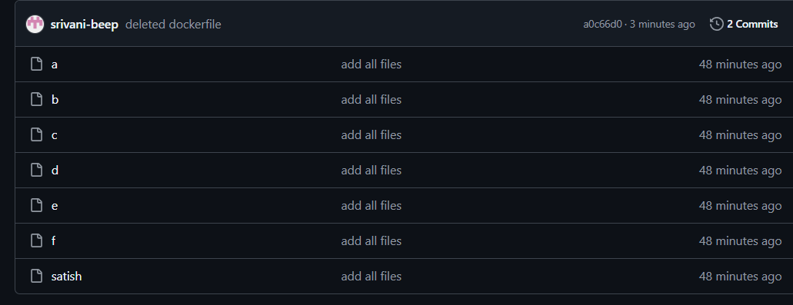

Scenario 2: If a file is created in GitHub, it will not appear in the local system until you pull the latest changes.

Step 1: create file in github
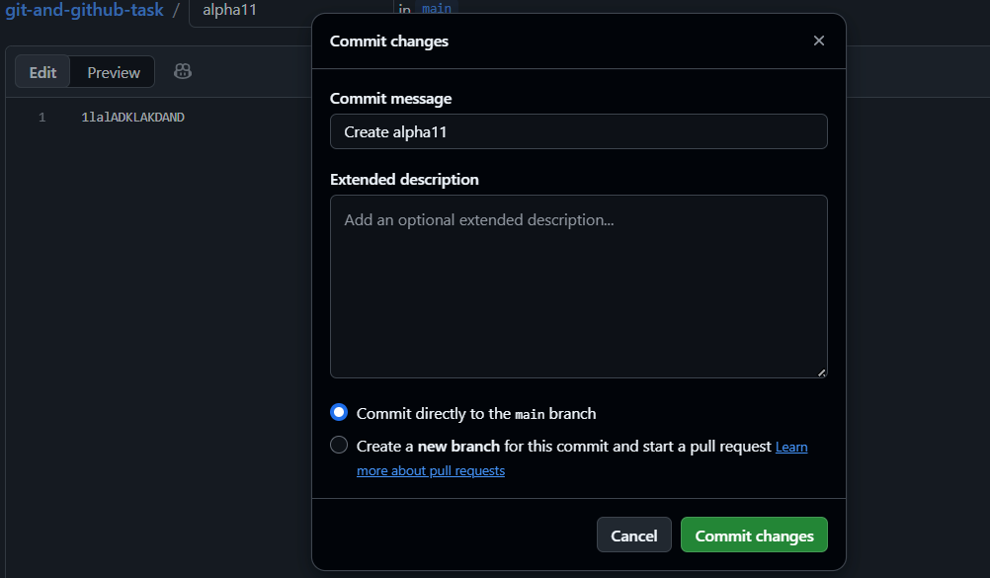

Step 2: create file in local system
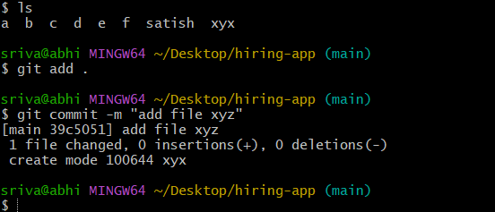

now if want to push the files it will through error because local and central repositories are not sync
command : git push -u origin main
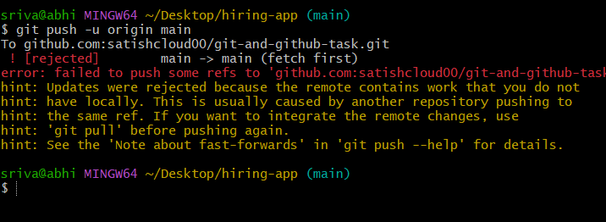
Step 3: central to local we need pull file
Command : fit pull
Command : ls
Now we can see alpha11 file in local machine
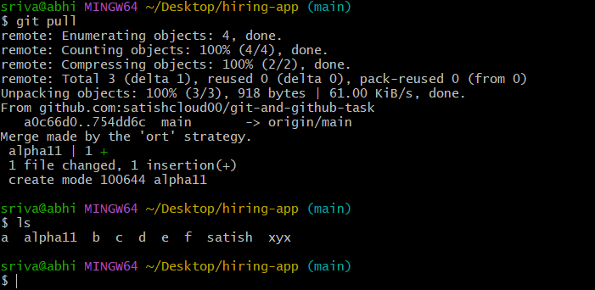

Step 4 : now push changes will be push to local to central
Command : git push -u origin main
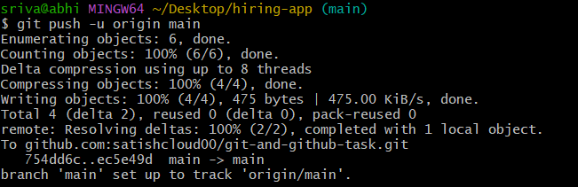

Local file xyz added and central repo file able to see in locak
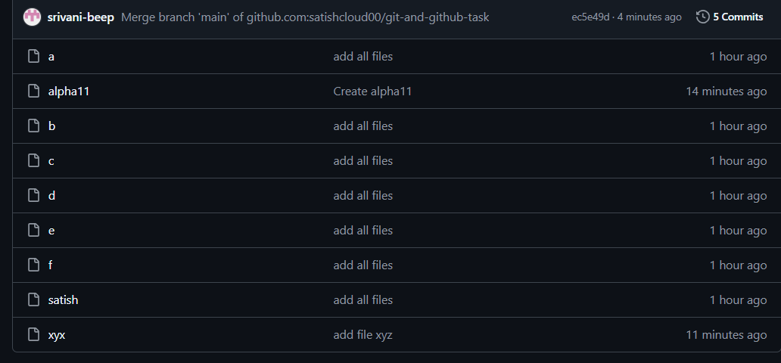

Git clone
Help us to download the source code form central to local
Command : git clone git@github.com:satishcloud00/git-and-github-task.git
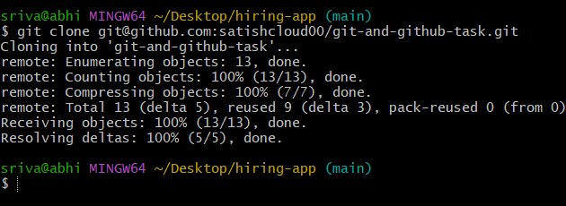
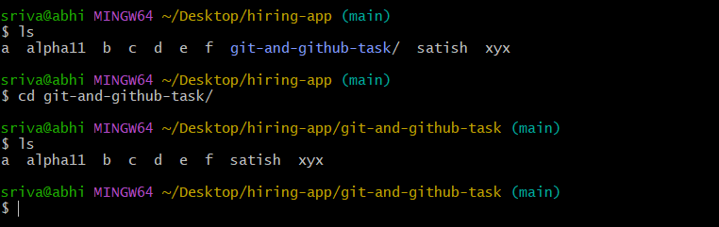

Scenario : of the directory deleted from local system how to download from central repo
Command : git clone
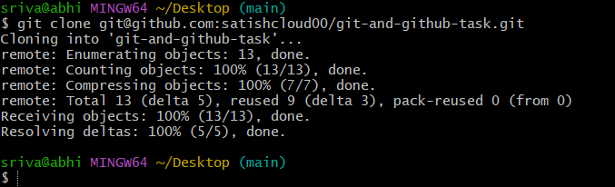
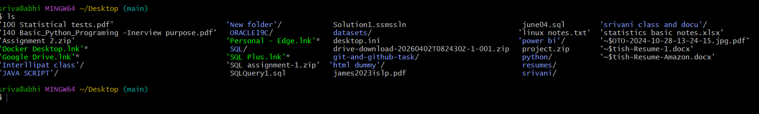

Scenario : how to retrieve deleted file
Command : git revert <commit id>
To know commit id we need run git log
Command : git log -4
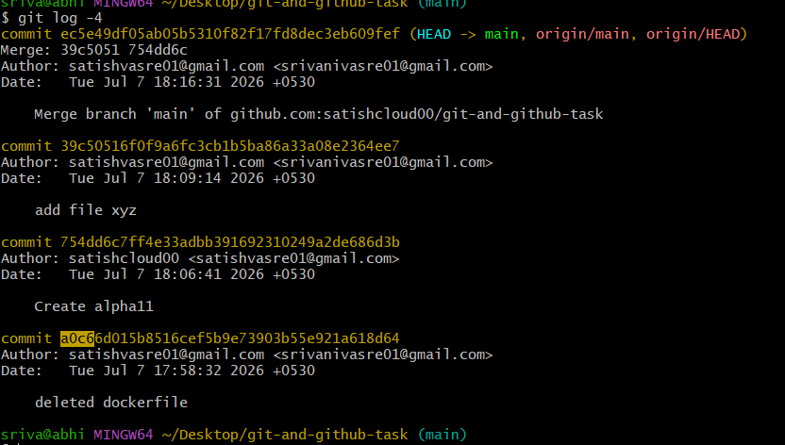
Now run
Command : git revert <commit id>
Dockerfile has been revert
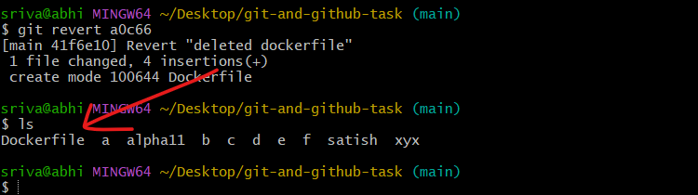

How to change track file to untrack file

Command : touch samplefile
Command : git add .
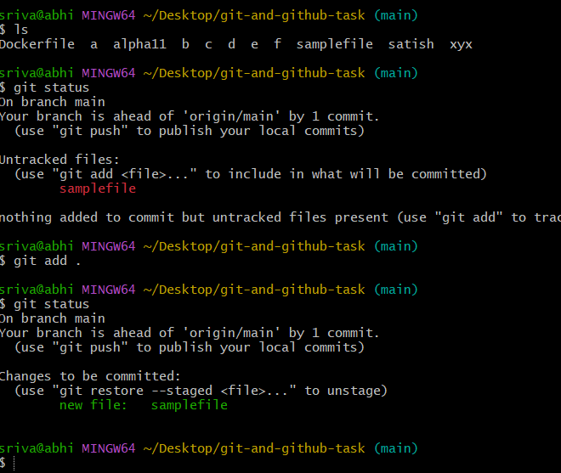

Now move to untrack
Command : git reset
